Network Traffic Prediction

Output

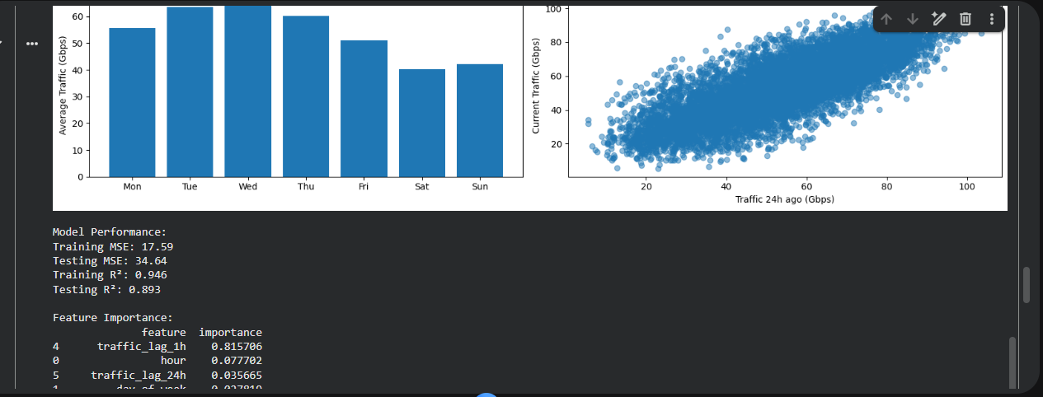
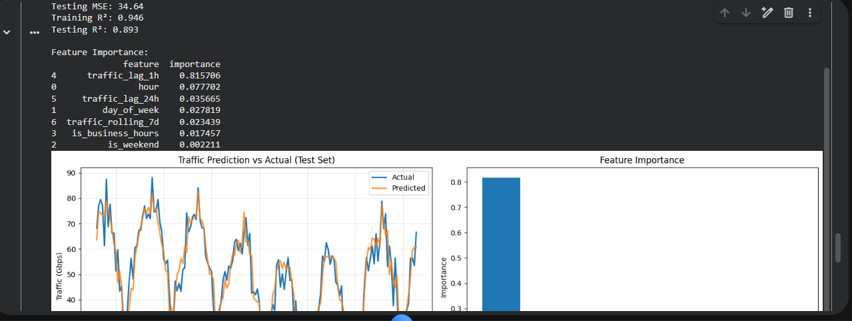
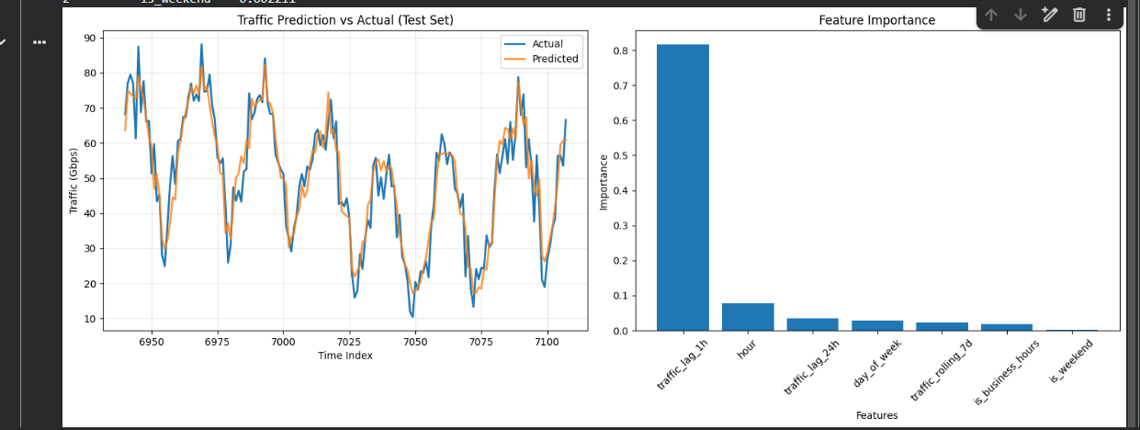

Code

import numpy as np
import pandas as pd
import matplotlib.pyplot as plt
from sklearn.model_selection import train_test_split
from sklearn.ensemble import RandomForestRegressor
from sklearn.metrics import mean_squared_error, r2_score
import seaborn as sns

# Generate synthetic telecom traffic data
np.random.seed(42)
dates = pd.date_range(start='2023-01-01', end='2023-12-31', freq='H')
n_samples = len(dates)

# Create realistic traffic patterns
hour = dates.hour
day_of_week = dates.dayofweek
day_of_year = dates.dayofyear

# Base traffic with daily and weekly patterns
base_traffic = (
50 + # Base level
20 * np.sin(2 * np.pi * hour / 24) + # Daily pattern
10 * np.sin(2 * np.pi * day_of_week / 7) + # Weekly pattern
5 * np.sin(2 * np.pi * day_of_year / 365) + # Annual pattern
np.random.normal(0, 5, n_samples) # Noise
)

# Add business hours boost
business_hours = (hour >= 9) & (hour <= 17) & (day_of_week < 5)
base_traffic += business_hours * 15

# Create DataFrame
traffic_data = pd.DataFrame({
'timestamp': dates,
'hour': hour,
'day_of_week': day_of_week,
'is_weekend': day_of_week >= 5,
'is_business_hours': business_hours,
'traffic_gbps': np.maximum(base_traffic, 0) # Ensure non-negative
})

# Feature engineering
traffic_data['traffic_lag_1h'] = traffic_data['traffic_gbps'].shift(1)
traffic_data['traffic_lag_24h'] = traffic_data['traffic_gbps'].shift(24)
traffic_data['traffic_rolling_7d'] = traffic_data['traffic_gbps'].rolling(
window=24*7, center=True
).mean()

# Remove rows with NaN values
traffic_data = traffic_data.dropna()

print("Dataset shape:", traffic_data.shape)
print("\nFirst few rows:")
print(traffic_data.head())

# Visualize the data
plt.figure(figsize=(15, 8))

plt.subplot(2, 2, 1)
plt.plot(traffic_data['timestamp'][:24*7], traffic_data['traffic_gbps'][:24*7])
plt.title('Traffic Pattern - One Week')
plt.xlabel('Time')
plt.ylabel('Traffic (Gbps)')
plt.xticks(rotation=45)

plt.subplot(2, 2, 2)
hourly_avg = traffic_data.groupby('hour')['traffic_gbps'].mean()
plt.bar(hourly_avg.index, hourly_avg.values)
plt.title('Average Traffic by Hour')
plt.xlabel('Hour of Day')
plt.ylabel('Average Traffic (Gbps)')

plt.subplot(2, 2, 3)
daily_avg = traffic_data.groupby('day_of_week')['traffic_gbps'].mean()
days = ['Mon', 'Tue', 'Wed', 'Thu', 'Fri', 'Sat', 'Sun']
plt.bar(days, daily_avg.values)
plt.title('Average Traffic by Day of Week')
plt.ylabel('Average Traffic (Gbps)')

plt.subplot(2, 2, 4)
plt.scatter(traffic_data['traffic_lag_24h'], traffic_data['traffic_gbps'], alpha=0.5)
plt.title('Traffic Autocorrelation (24h lag)')
plt.xlabel('Traffic 24h ago (Gbps)')
plt.ylabel('Current Traffic (Gbps)')

plt.tight_layout()
plt.show()

# Prepare features and target
feature_columns = [
'hour', 'day_of_week', 'is_weekend', 'is_business_hours',
'traffic_lag_1h', 'traffic_lag_24h', 'traffic_rolling_7d'
]

X = traffic_data[feature_columns]
y = traffic_data['traffic_gbps']

# Split the data
X_train, X_test, y_train, y_test = train_test_split(
X, y, test_size=0.2, random_state=42, shuffle=False
)

# Train Random Forest model
rf_model = RandomForestRegressor(
n_estimators=100,
max_depth=10,
random_state=42,
n_jobs=-1
)

rf_model.fit(X_train, y_train)

# Make predictions
y_pred_train = rf_model.predict(X_train)
y_pred_test = rf_model.predict(X_test)

# Evaluate the model
train_mse = mean_squared_error(y_train, y_pred_train)
test_mse = mean_squared_error(y_test, y_pred_test)
train_r2 = r2_score(y_train, y_pred_train)
test_r2 = r2_score(y_test, y_pred_test)

print(f"\nModel Performance:")
print(f"Training MSE: {train_mse:.2f}")
print(f"Testing MSE: {test_mse:.2f}")
print(f"Training R²: {train_r2:.3f}")
print(f"Testing R²: {test_r2:.3f}")

# Feature importance
feature_importance = pd.DataFrame({
'feature': feature_columns,
'importance': rf_model.feature_importances_
}).sort_values('importance', ascending=False)

print(f"\nFeature Importance:")
print(feature_importance)

# Plot predictions vs actual
plt.figure(figsize=(15, 6))
test_indices = X_test.index[:168] # Show one week of test data

plt.subplot(1, 2, 1)
plt.plot(test_indices, y_test.loc[test_indices], label='Actual', linewidth=2)
plt.plot(test_indices, y_pred_test[:len(test_indices)],
label='Predicted', linewidth=2, alpha=0.8)
plt.title('Traffic Prediction vs Actual (Test Set)')
plt.xlabel('Time Index')
plt.ylabel('Traffic (Gbps)')
plt.legend()
plt.grid(True, alpha=0.3)

plt.subplot(1, 2, 2)
plt.bar(feature_importance['feature'], feature_importance['importance'])
plt.title('Feature Importance')
plt.xlabel('Features')
plt.ylabel('Importance')
plt.xticks(rotation=45)

plt.tight_layout()
plt.show()

